Group 15

Interactive Data Visualization

Lab 4

|  |  |
| --- | --- |
| Dhruvi Mehta | 202318003 |
| Prachi Mehta | 202318008 |
| Riya Dave | 202318011 |
| Simran Dalvi | 202318042 |

Part 1

1. What are the top 10 products that have the longest delivery times?

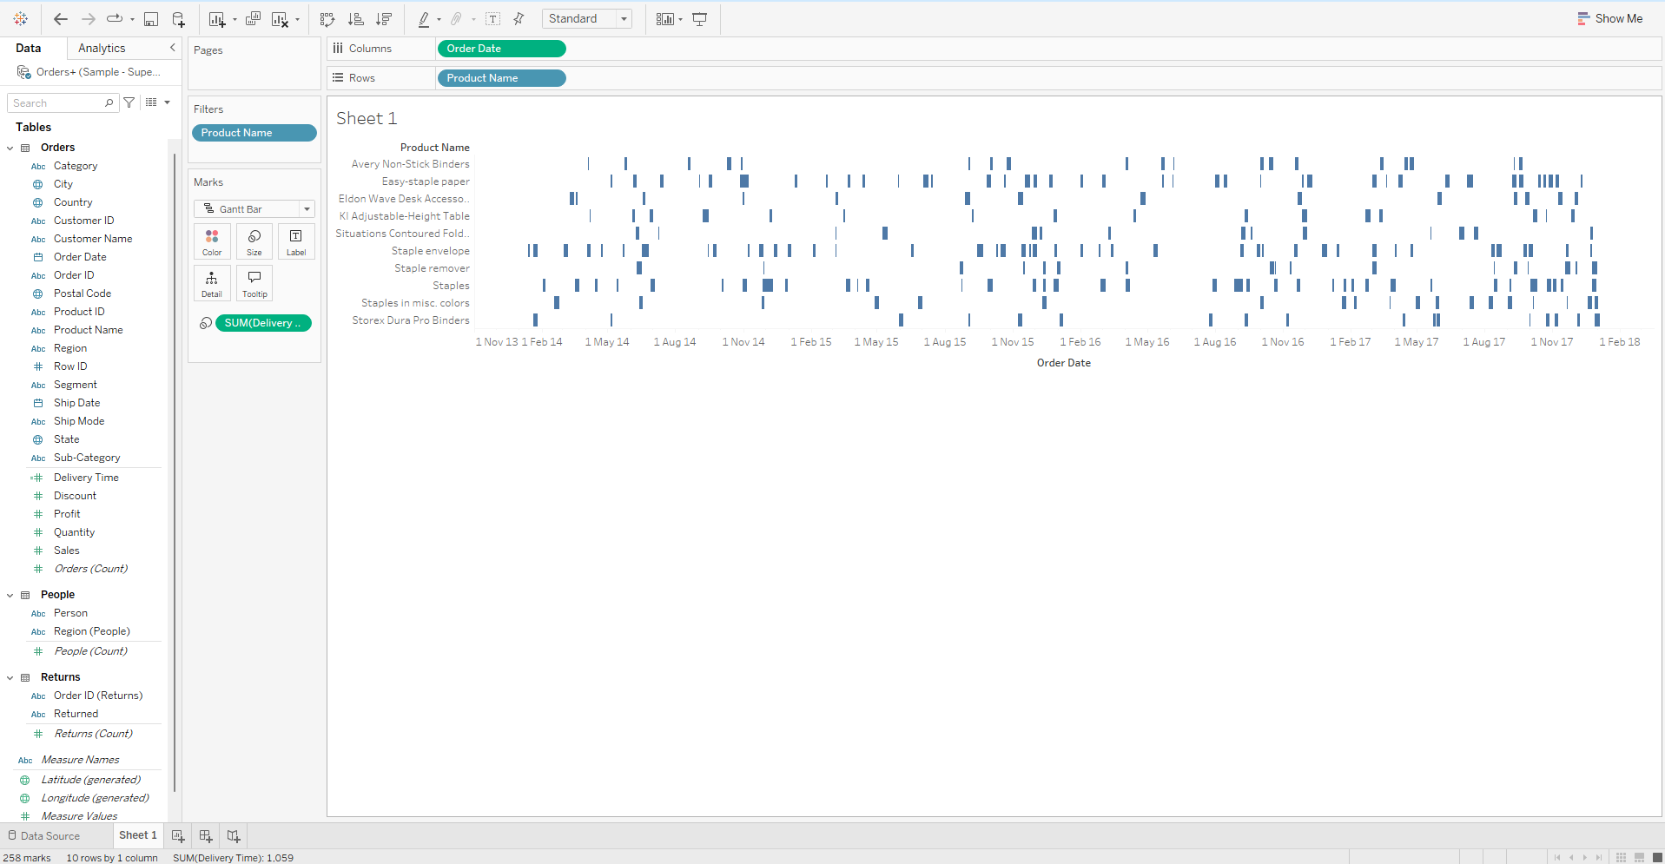

1. Do order processing times change significantly during certain months or

seasons?

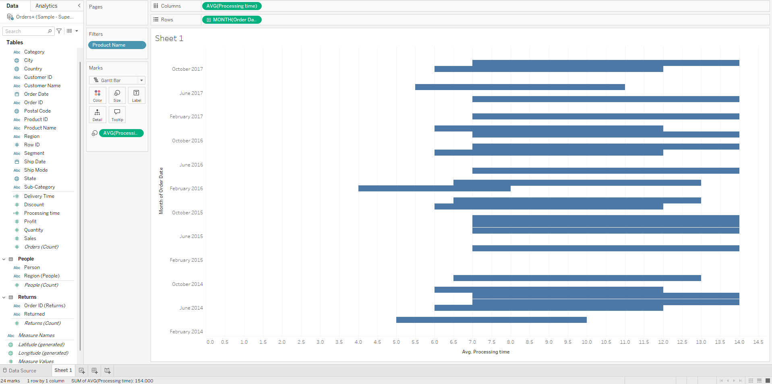

1. Represent quantity sold for each category in its respective year.

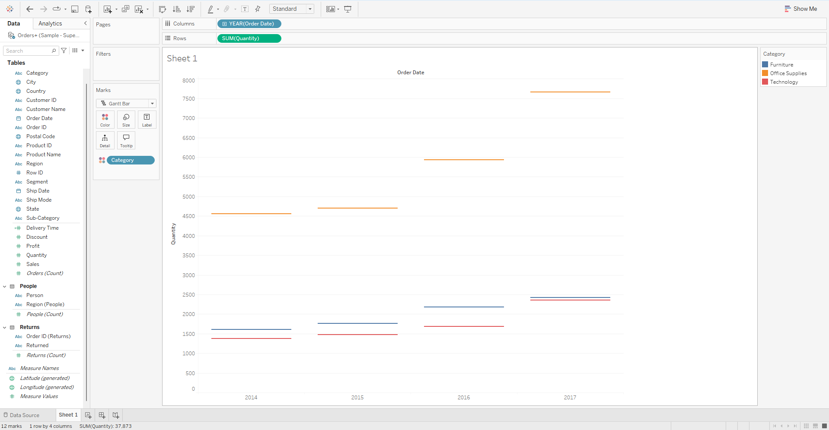

1. Can we compare the shipping times for different shipping modes (Standard,

Second Class, etc.) over time?

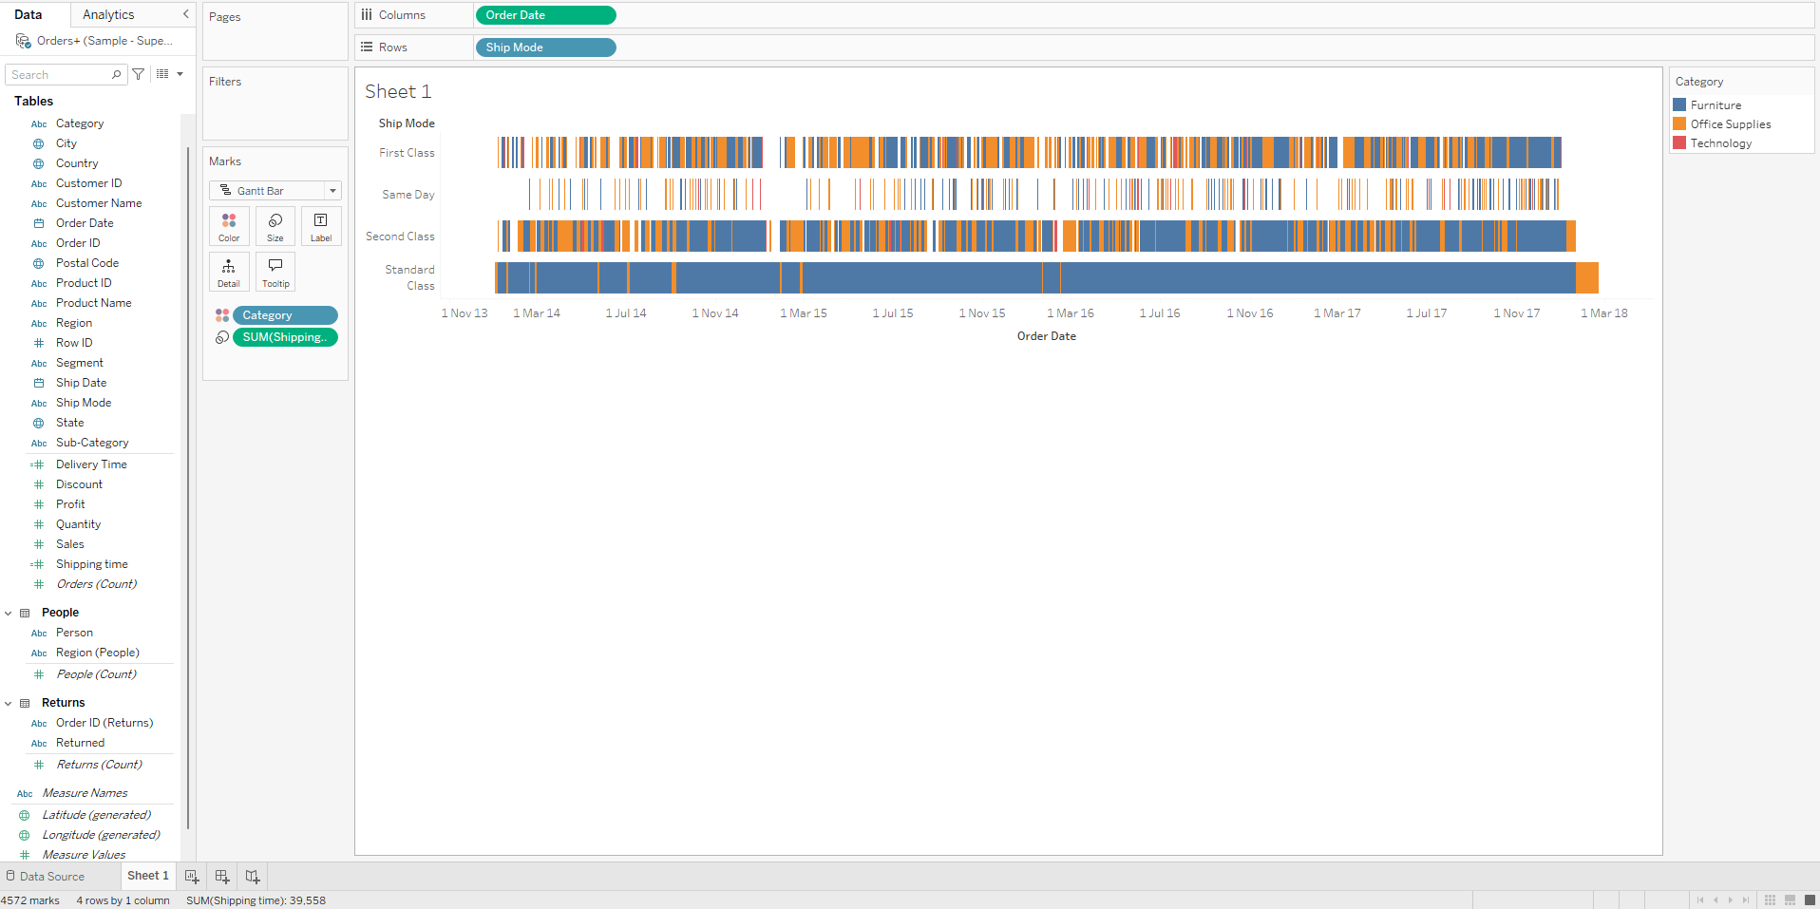

1. Is there any correlation between the number of items in an order and the time it

takes to process and ship that order?

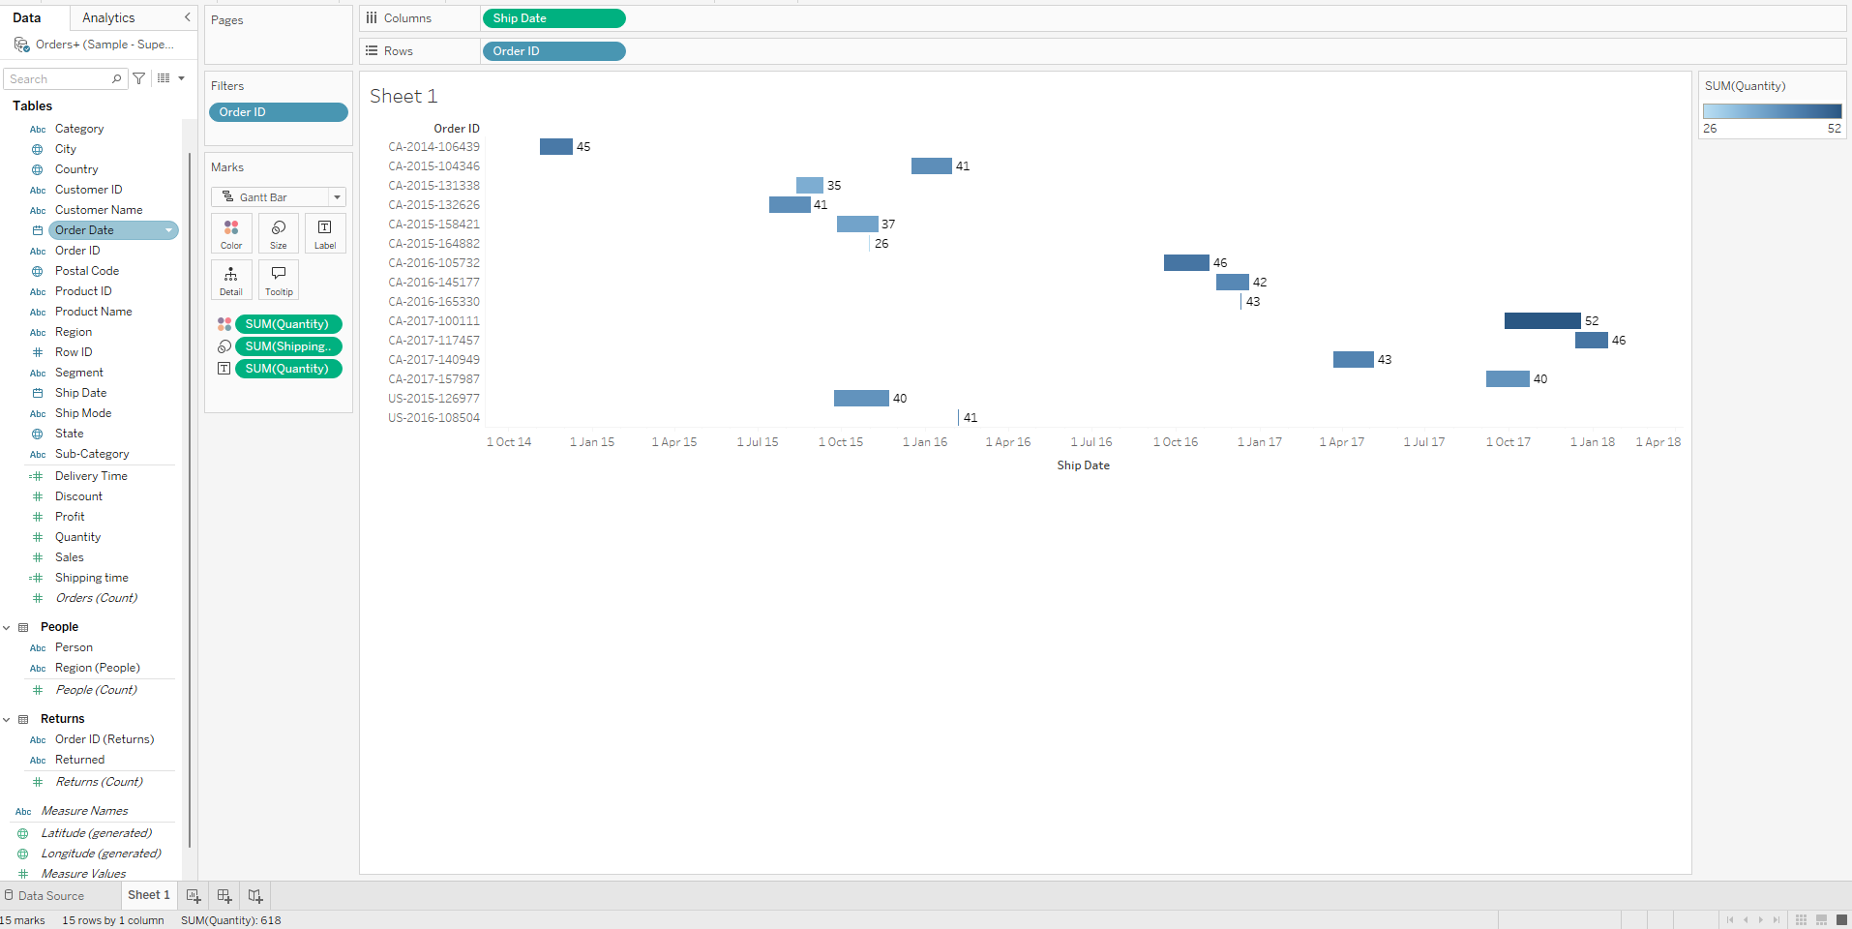

Part 2

Superstore dataset

